**EEG AI driven neuro feedback system flowchart which focuses on Feedback**

**T.Nikhitha**

**AIE-23133(E-SEC),4th Sem**

**Machine Learning**

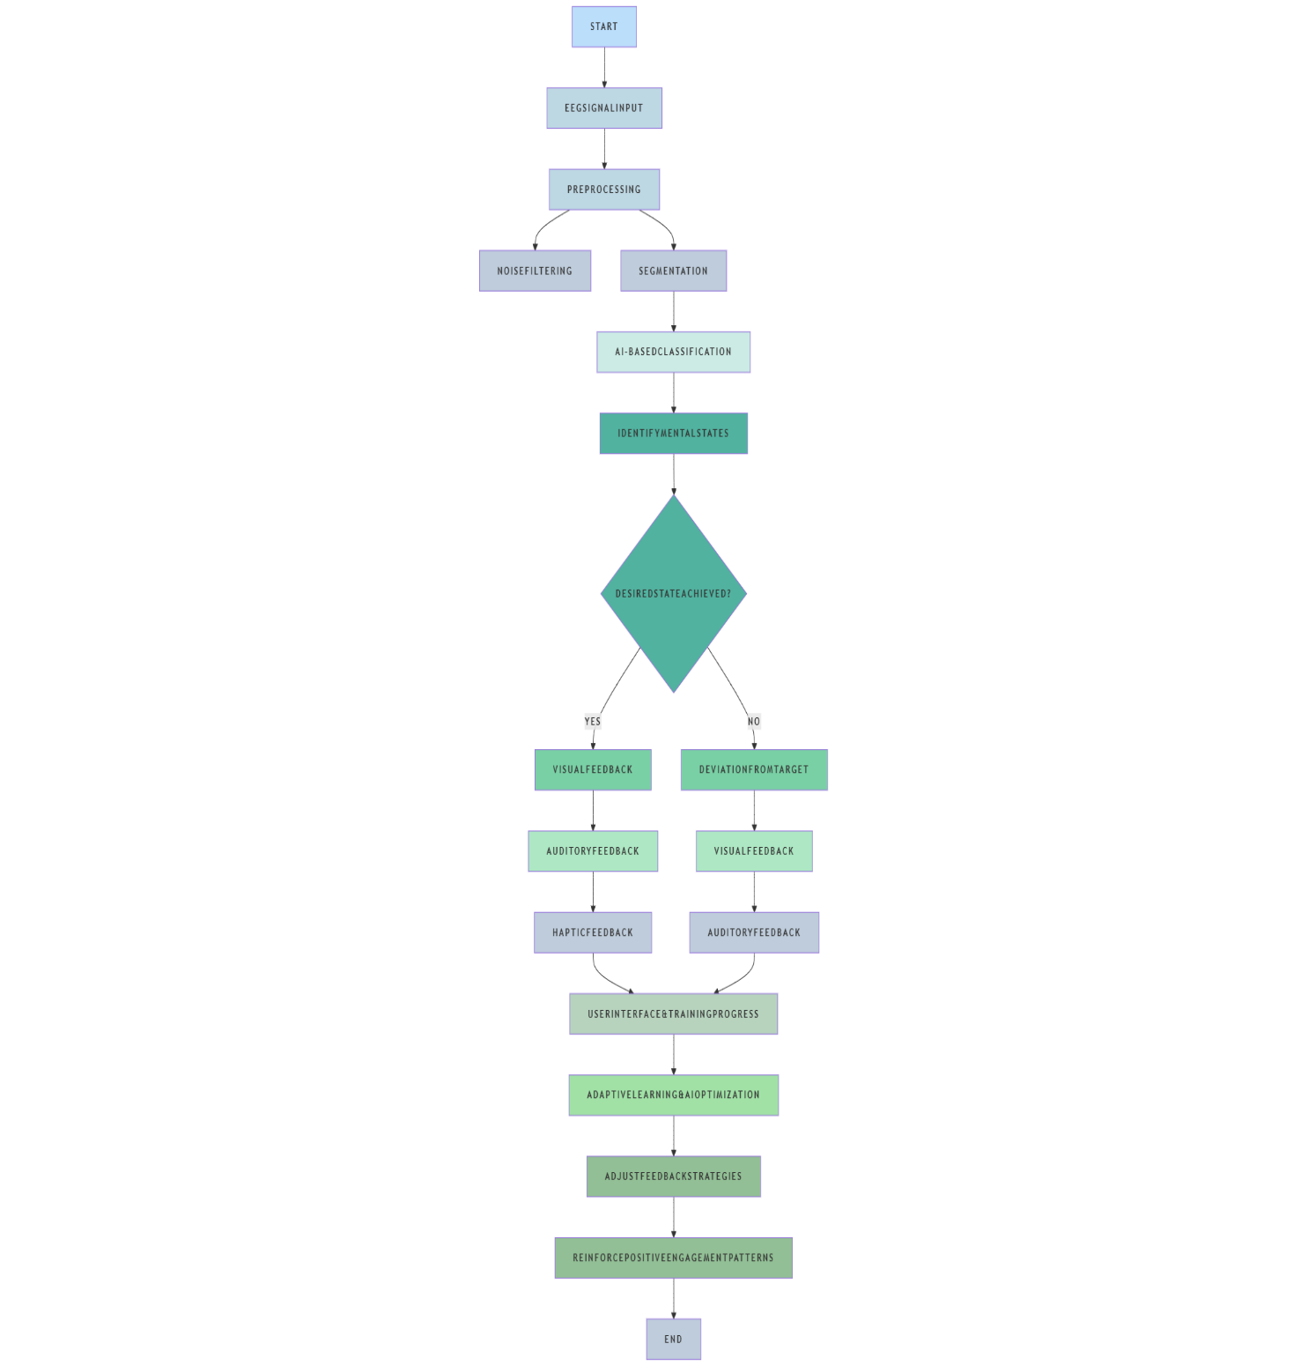

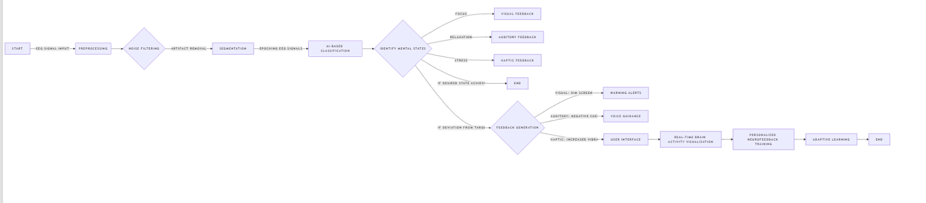

This flowchart depicts an EEG AI-based Neurofeedback System, highlighting feedback processes for brain training and cognitive improvement. The following is a step-by-step explanation of the flowchart:

Start – The process of the system starts.

EEG Signal Input – The system takes raw EEG signals from the user.

Preprocessing – The EEG data is cleaned and prepared for processing.

Noise Filtering – Eliminates artifacts and noise that should not be present in the signal.

Segmentation – Splits the EEG data into useful time segments for improved analysis.

AI-Based Classification – The system uses machine learning models to classify states of the brain.

Identify Mental States – The system identifies the user's present state of mind or emotional state.

Desired State Achieved? – A decision step that determines whether the user has achieved the desired mental state.

Yes:

Provides Visual Feedback (e.g., altering screen brightness or colors).

Provides Auditory Cues (e.g., nice sounds or tones).

Provides Haptic Cues (e.g., vibrations to affirm success).

No (Deviation from target state):

Provides Visual Cues to signal deviation.

Provides Auditory Cues to correct cognitive state.

User Interface Training Process – The AI engages with the user to coach them towards the target state.

Adaptive Learning & Optimization – The AI learns and customizes feedback techniques with time.

Adjust Feedback Strategies – The system adjusts feedback according to user response.

Reinforce Positive Engagement Patterns – Motivates the user to remain engaged and enhance performance.

End – The process ends.